Bios for AWIS-PHL Board of Officers Election 2026-2027

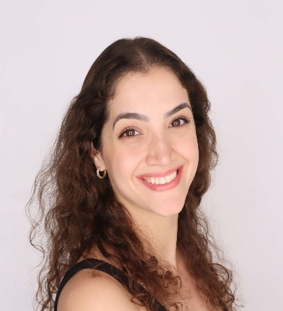
Samar Nasser Chehimi, PhD

Candidate for President-Elect

Samar received her PhD in Human Genetics from the University of São Paulo (Brazil) and moved to the US for her post-doctoral training at the Children’s Hospital of Philadelphia and then University of Pennsylvania (UPenn). Currently, she works as a senior Research Specialist at UPenn in a neurogenetics lab studying the molecular basis of hedonic behaviors and investigating the reward system of the brain.

She joined AWIS-PHL in 2022 as a mentee and has been a proud member ever since. During that time, she has transitioned to a Social Media Chair role and acted as a mentor for one of the mentoring circles.

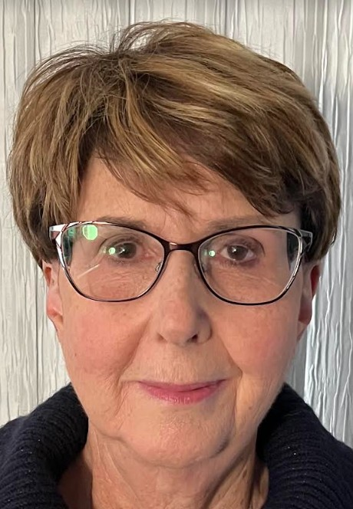
Mary Barnette, Ph.D.

Candidate for Treasurer

I am a retired scientist, pharmacologist. My career spans 30+ years in the pharmaceutical industry in both drug discovery and development. During that time, I have led both drug discovery teams and development teams. In discovery, I focused on identifying clinical drug candidates for the treatment of gastrointestinal diseases (GERD and IDB) and respiratory diseases (asthma and COPD). In development, my work focused on identifying and implementing clinical biomarkers in early stage oncology drug clinical trials. To facilitate both the discovery and development processes, I have experience in managing CROs, setting up contracts, and managing the budgets for these efforts.
Since my retirement, I have become more involved in AWIS, participating in the mentoring program these past 2 years. My other interests include: 1. Volunteering as a poll worker at my local precinct; 2. Leading a book club; 3. Ice dancing and participating in my local figure skating club as the test chairperson; 4. Teaching skating skills to adults as a Learn to Skate instructor; 5. Acting as a judge for Pennsylvania State High School STEM competition.

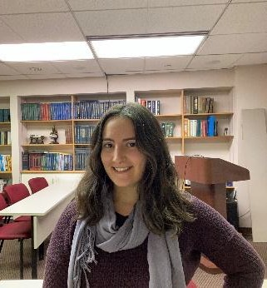
Chloe Azadegan

Candidate for Secretary
Chloe is a Ph.D. candidate in the Drexel University MCBG (Molecular and Cell Biology & Genetics) program and is currently working on cancer epigenetics research at the Fox Chase Cancer Center. She received her bachelor’s degree in Cell Biology and Neuroscience from Rutgers University and held a 2-year co-op position at Colgate-Palmolive's Early R&D branch.
Chloe discovered AWIS through her involvement in the AWIS-PHL mentoring circles and has enjoyed the community gained through her membership. She has served on the AWIS-PHL board as Secretary since 2023 and is proud to be involved in the decision-making of such a respectable and supportive chapter. She hopes to continue growing as a researcher and leader within the Drexel and AWIS communities and aims to encourage and inspire young women to achieve their goals in STEM careers.

